

**Green University of Bangladesh**

**Department of Computer Science and Engineering (CSE)**

**Faculty of Sciences and Engineering**

**Semester: (Spring, Year:2021), B.Sc. in CSE (Day/Eve)**

**Course Title: Data Structure Lab**

**Course Code: CSE 106 Section: DC**

**Lab Project Name: Canteen Management**

**Student Details**

| **Name** | | **ID** |
| --- | --- | --- |
| **1.** | Tasnim Ahmed Tapoy | 213902111 |

**Submission Date : 11 September 2022**

**Course Teacher’s Name : Md. Sultanul Islam Ovi**

**[For Teachers use only: Don’t Write Anything inside this box]**

| **Lab Project Status**  **Marks: ………………………………… Signature: .....................**  **Comments: .............................................. Date: ..............................** |
| --- |

Table of Contents

**Chapter 1 Introduction 3**

1.1 Introduction 3

1.2 Design Goals/Objective 3

**Chapter 2 Implementation of the Project 4**

2.1 Flow Charts

2.2 Implementation 4

2.3. SreenShots of Output 4

**Conclusion 6**

3.1 Introduction 6

3.2 Practical Implications 6

3.3 Scope of Future Work 6

**References 7**

# Chapter 1 Introduction

## Introduction

C is a general-purpose computer programming language. It was created in the 1970s by Dennis Ritchie, and remains very widely used and influential. By design, C's features cleanly reflect the capabilities of the targeted CPUs

Canteen management system is specially designed for the purpose of calculating total bill in a canteen and adding ordered item’s record. This system elaborates basic concept for storing and generating ordered item’s detail. In this system, staff can sign up as a system admin, He/she can have full access to the system for maintaining daily records. The whole project is designed in ‘C’ language and different variables and strings have been used for the development of this project. It’s easy to operate and understand by users. There is no any error and warning contents in the project. The design is so simple that user should not find it difficult to use and navigate.

## 

## Design Goals/Objective

. The main aim of designing and developing this Internet

Canteen Management System C language primarily based . Engineering project is to provide secure and efficient students for order or getting bill from customers over the internet.

1. Proper Validations.
2. Proper Log in system.
3. Easy to add, edit, view, search and delete order details.
4. Calculation of total bill.

In our canteen there are so many students so that canteen helper or manager cant controll them properly. So that Many problem face some one get there order , some one order and pay bill but not recived order there are so many problem happnes. So that we made that project for help them. Student can order there product by that and pay bill, delete bill so many things can do.

# Chapter 2

# Implementation of the Project

## Flow Chart

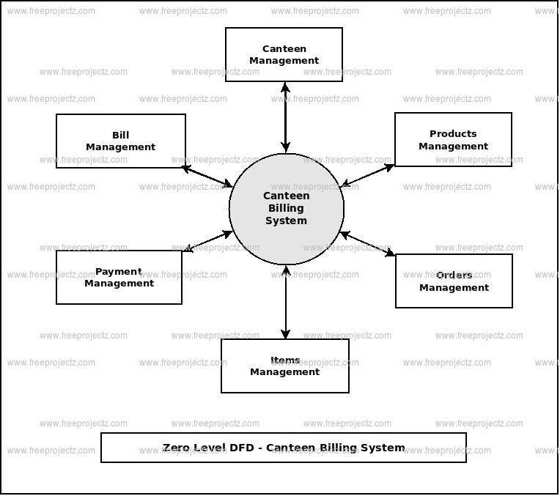

* 1. **Implementation**

#include<stdio.h>

#include<conio.h>

#include<stdlib.h>

#include<string.h>

#include<ctype.h>

#include<windows.h>

#define ANS 15

#define ACS 4

COORD coord= {0,0}; // this is global variable

void gotoxy(int x,int y)

{

coord.X=x;

coord.Y=y;

SetConsoleCursorPosition(GetStdHandle(STD_OUTPUT_HANDLE),coord);

}

/*declaration of checking functions*/

void c_code(char[]);

int check(char[]);

/*structure declaration*/

typedef struct

{

char name[ANS],code[ACS];

float rate;

int quantity;

} rec;

rec item;

/*declaration of display functions*/

void curser(int);

void dbill();

void d_mainmenu();

void display(rec *,int,int);

void window(int,int,int,int);

void dis_con();

void d_search();

void highlight(int,int);

/*declaration of main menu functions*/

void bill() ;

void edit();

void add();

void del();

void exit();

/*declaration of display submenu functions*/

void d_code();

void d_rate();

void d_quan();

void d_all();

void login()

{

int a=0,i=0;

char uname[10],c=' ';

char pword[10],code[10];

char user[10]="Tapoy";

char pass[10]="111";

do

{

printf("\n LOGIN FORM ");

printf(" \n\n ENTER USERNAME:-");

scanf("%s", &uname);

printf(" \n\n ENTER PASSWORD:-");

while(i<10)

{

pword[i]=getch();

c=pword[i];

if(c==13) break;

else printf("*");

i++;

}

pword[i]='\0';

i=0;

if(strcmp(uname,"Tapoy")==0 && strcmp(pword,"111")==0)

{

printf(" \n\n\n WELCOME TO CAFETERIA ORDER SYSTEM !!!! LOGIN IS SUCCESSFUL");

printf("\n\n\n\t\t\t\tPress any key to continue...");

getch();//holds the screen

break;

}

else

{

printf("\n SORRY !!!! LOGIN IS UNSUCESSFUL");

a++;

getch();//holds the screen

}

}

while(a<=2);

if (a>2)

{

printf("\nSorry you have entered the wrong username and password for four times!!!");

getch();

}

system("cls");

}

/*start of main*/

int main()

{

login();

d_mainmenu();

return 0;

}

void d_mainmenu()

{

int i;

char ch;

const char *menu[]= {" Calculate Bill"," Order Items"," Edit Items"," Display Orders "," Search Orders", " Delete Orders"," Exit"};

system("cls");

//textbackground(11);

//textcolor(0);

//_setcursortype(_NOCURSOR);

window(25,50,20,32);

gotoxy(33,18);

printf("CAFE MENU");

for (i=0; i<=6; i++)

{

gotoxy(30,22+i+1);

printf("%s\n\n\n",menu[i]);

}

curser(7);

}

void d_search()

{

char ch;

int i;

const char *menu[]= {" By Code"," By Rate"," By Quantity"," Back to main menu"};

system("cls");

//textbackground(11);

//textcolor(0);

window(25,50,20,32);

gotoxy(33,18);

printf("SEARCH MENU");

for (i=0; i<=3; i++)

{

gotoxy(30,22+i+1);

printf("%s\n\n\n",menu[i]);

}

curser(4);

}

/*function for cursor movement*/

void curser(int no)

{

int count=1;

char ch='0';

gotoxy(30,23);

while(1)

{

switch(ch)

{

case 80:

count++;

if (count==no+1) count=1;

break;

case 72:

count--;

if(count==0) count=no;

break;

}

highlight(no,count);

ch=getch();

if(ch=='\r')

{

if(no==7)

{

if (count==1) bill() ;

else if(count==2) add();

else if(count==3) edit();

else if (count==4) d_all();

else if (count==5) d_search();

else if (count==6) del();

else exit(0);

}

if(no==4)

{

if (count==1) d_code();

else if (count==2)d_rate();

else if (count==3) d_quan();

else d_mainmenu();

}

}

}

}

void highlight(int no,int count)

{

if (no==4)

{

//textbackground(11);

//textcolor(0);

gotoxy(30,23);

printf(" By Code ");

gotoxy(30,24);

printf(" By Rate ");

gotoxy(30,25);

printf(" By Quantity ");

gotoxy(30,26);

printf(" Back to main menu");

//textcolor(0);

//textbackground(2);

switch (count)

{

case 1:

gotoxy(30,23);

printf(" - By Code ");

break;

case 2:

gotoxy(30,24);

printf(" - By Rate ");

break;

case 3:

gotoxy(30,25);

printf(" - By Quantity ");

break;

case 4:

gotoxy(30,26);

printf(" - Back to main menu");

break;

}

}

if(no==7)

{

//textbackground(11);

//textcolor(0);

gotoxy (30,23);

printf(" Calculate Bill ");

gotoxy (30,24);

printf(" Add Orders ");

gotoxy (30,25);

printf(" Edit Orders ");

gotoxy (30,26);

printf(" Display Orders ");

gotoxy (30,27);

printf(" Search ");

gotoxy (30,28);

printf(" Delete Orders ");

gotoxy (30,29);

printf(" Exit ");

//textcolor(0);

//textbackground(2);

switch(count)

{

case 1:

gotoxy (30,23);

printf(" - Calculate Bill ");

break;

case 2:

gotoxy (30,24);

printf(" - Add Orders ");

break;

case 3:

gotoxy (30,25);

printf(" - Edit Orders ");

break;

case 4:

gotoxy (30,26);

printf(" - Display Orders ");

break;

case 5:

gotoxy (30,27);

printf(" - Search ");

break;

case 6:

gotoxy (30,28);

printf(" - Delete Orders ");

break;

case 7:

gotoxy (30,29);

printf(" - Exit ");

break;

}

}

}

void bill()

{

char x[4]= {0};

int j=29,q=0,size=0,i=1;

float total=0,gtotal=0;

FILE *file;

file=fopen("record.txt","r+b");

rewind(file);

system("cls");

dbill();

gotoxy(26,15);

printf("Enter \"end\" to finish input");

while(1)

{

gotoxy(25,18);

printf(" ");

gotoxy(25,19);

printf(" ");

gotoxy(25,18);

printf("Enter Item Code:");

scanf("%s",x);

if(strcmp(x,"end")==0)

break;

gotoxy(25,19);

printf("Enter Quantity:");

scanf("%d",&q);

rewind(file);

while(fread(&item,sizeof(item),1,file))

{

if((strcmp(item.code,x)==0))

{

total=item.rate*q;

gotoxy(11,j);

printf("%4d",i);

printf("%9s",item.name);

printf("%13d",q);

printf("%15.2f",item.rate);

printf("%13.2f",total);

gtotal=gtotal+total;

size=sizeof(item);

item.quantity=item.quantity-q;

j+=2;

i++;

fseek(file,-size,SEEK_CUR);

fwrite(&item,sizeof(item),1,file);

break;

}

}

}

if(gtotal!=0)

{

gotoxy(30,j+5);

printf("TOTAL AMOUNT = NRs. %6.2f",gtotal);

}

fclose(file);

getch();

d_mainmenu();

}

/*function to display bill window*/

void dbill()

{

int i;

gotoxy(20,10);

//;

for (i=1; i<=10; i++)

printf("-");

printf(" ABC ");

for (i=1; i<=10; i++)

printf("-");

printf("\n\n");

gotoxy(30,11);

printf("CAFE");

//textcolor(1);

gotoxy(32,25);

printf("CUSTOMER'S BILL") ;

//textcolor(8);

gotoxy(13,27);

printf("SN. Item Name Quantity Rate Total");

}

/*function to add records*/

void add ()

{

FILE *file;

char y[ACS],x[12];

system("cls");

//textbackground(11);

//textcolor(0);

gotoxy(25,25);

printf("Enter New Record(Y/N)?");

while(toupper(getche())=='Y')

{

system("cls");

file=fopen("record.txt","ab");

c_code(y);

strcpy(item.code,y);

gotoxy(22,28);

printf("Enter Rate Of The Item:");

scanf("%f",&item.rate);

gotoxy(22,30);

printf("Enter Quantity Of The Item:");

scanf("%d",&item.quantity);

gotoxy(22,32);

printf("Enter Name Of The Item:");

scanf("%s",item.name);

fseek(file,0,SEEK_END);

fwrite(&item,sizeof(item),1,file);

fclose(file);

gotoxy(22,34);

printf("Enter New Record(Y/N)?");

}

d_mainmenu();

}

/*function to check availability of code*/

void c_code(char y[])

{

int flag;

FILE *file;

file=fopen("record.txt","rb");

while(1)

{

system("cls");

window(20,58,23,36);

gotoxy(32,18);

printf(" ADD ORDERS ") ;

flag=1;

rewind(file);

gotoxy(22,25);

printf("Enter New Code Of Item:");

scanf(" %[^\n]",y);

while(fread(&item,sizeof(item),1,file)==1)

{

if (strcmp(y,item.code)==0)

{

flag=0;

gotoxy(26,30);

printf("Code Already Exists");

gotoxy(29,32);

printf("Enter Again");

getch();

break;

}

}

if (flag==1)

break;

}

}

/*function for editing*/

void edit()

{

int flag=0,choice;

char x[ACS],y[ACS];

FILE *file;

int size;

system("cls");

//textcolor(0);

//textbackground(11);

window(20,63,20,46);

gotoxy(35,18);

printf("EDIT ORDERS");

;

gotoxy(25,23);

printf("Enter Item Code: ");

scanf("%s",x);

flag=check(x);

if(flag==0)

{

file=fopen("record.txt","r+b");

rewind(file);

while (fread(&item,sizeof (item),1,file))

{

if(strcmp(item.code,x)==0)

{

//textcolor(0);

gotoxy(25,27);

printf("name = %s",item.name);

gotoxy(25,28);

printf("code = %s",item.code);

gotoxy(25,29);

printf("rate = %g",item.rate);

gotoxy(25,30);

printf("quantity = %d",item.quantity);

gotoxy(25,32);;

printf("Do You Want To Edit This Record?(y/n):");

fflush(file);

if(toupper(getche())=='Y')

{

//textcolor(0);

gotoxy(25,34);

printf("1- Edit Name ");

gotoxy(25,35);

printf("2- Edit Code ");

gotoxy(25,36);

printf("3- Edit Rate ");

gotoxy(25,37);

printf("4- Edit Quantity ");

gotoxy(25,39); ;

printf(" Enter Your Choice(1, 2, 3, 4) ");

scanf("%d",&choice);

switch(choice)

{

case 1:

system("cls");

window(23,48,20,40);

gotoxy(35,18);

printf("EDIT RECORDS");

gotoxy(25,24);

printf(" Enter New Name: ");

scanf("%s",item.name);

size=sizeof(item);

fseek(file,-size,SEEK_CUR);

fwrite(&item,sizeof(item),1,file);

break;

case 2:

system("cls");

window(23,65,20,40);

gotoxy(35,18);

printf("EDIT RECORDS");

gotoxy(25,24);

c_code(y);

strcpy(item.code,y);

size=sizeof(item);

fseek(file,-size,SEEK_CUR);

fwrite(&item,sizeof(item),1,file);

break;

case 3:

system("cls");

window(23,65,20,40);

gotoxy(35,18);

printf("EDIT RECORDS");

gotoxy(25,24);

printf(" Enter New Rate: ");

scanf("%f",&item.rate);

size=sizeof(item);

fseek(file,-size,SEEK_CUR);

fwrite(&item,sizeof(item),1,file);

break;

case 4:

system("cls");

window(23,65,20,40);

gotoxy(35,18);

printf("EDIT RECORDS");

gotoxy(25,24);

printf(" Enter New Quantity: ");

scanf("%d",&item.quantity);

size=sizeof(item);

fseek(file,-size,1);

fwrite(&item,sizeof(item),1,file);

break;

}

gotoxy(27,30);

printf("--- Item Edited---");

break;

}

}

}

}

if (flag==1)

{

gotoxy(32,30);

printf("Item Does Not Exist.");

gotoxy(36,32);

printf("TRY AGAIN");

}

getch();

fclose(file);

d_mainmenu();

}

/*function to display all records*/

void d_all()

{

int i,j=1;

FILE *file;

dis_con();

file=fopen("record.txt","rb");

rewind(file);

i=26;

fflush(file);

while(fread(&item,sizeof(item),1,file))

{

display(&item,i,j);

i++;

j++;

if ((j%20)==0)

{

gotoxy(27,47);/*textcolor(0)*/;

printf("Press Any Key To See More...........");

getch();

system("cls");

dis_con();

i=26;

continue;

}

}

getch();

if (i==26)

{

gotoxy(24,30);

printf("-- No Order Found --");

}

getch();

fclose(file);

d_mainmenu();

}

/*function to display by quantity*/

void d_quan()

{

int i,j=1;

int a,b;

FILE *file;

dis_con();

file=fopen("record.txt","rb");

rewind(file);

i=26;

gotoxy(16,20);;

printf("Enter Lower Range: ");

scanf("%d",&a);

gotoxy(16,21);

printf("Enter Upper Range:");

scanf("%d",&b);

fflush(file);

while(fread(&item,sizeof(item),1,file))

{

if((item.quantity>=a)&&(item.quantity<=b))

{

display(&item,i,j);

i++;

j++;

if ((j%20)==0)

{

gotoxy(27,47);

printf("Press Any Key To See More......");

getch();

system("cls");

dis_con();

i=26;

continue;

}

}

}

getch();

if (i==26)

{

gotoxy(28,30);

printf(" No Items Found.");

}

getch();

d_search();

fclose(file);

}

/*function to display by rate*/

void d_rate()

{

int i,j=1;

float a,b;

FILE *file;

dis_con();

file=fopen("record.txt","rb");

rewind(file);

i=26;

gotoxy(16,20);;

printf("Enter Lower Range: ");

scanf("%f",&a);

gotoxy(16,21);

printf("Enter Upper Range: ");

scanf("%f",&b);

fflush(file);

while(fread(&item,sizeof(item),1,file))

{

if((item.rate>=a)&&(item.rate<=b))

{

display(&item,i,j);

i++;

j++;

if ((j%20)==0)

{

gotoxy(27,47);

printf("Press Any Key To See More.....");

getch();

system("cls");

dis_con();

i=26;

continue;

}

}

}

getch();

if (i==26)

{

gotoxy(28,30);

printf(" No Item Found ");

}

getch();

fclose(file);

d_search();

}

/*function to display by code*/

void d_code()

{

int i,j=1;

char x[4]= {0};

FILE *file;

dis_con();

file=fopen("record.txt","rb");

rewind(file);

i=26;

gotoxy(16,20);;

printf("Enter Item Code: ");

scanf("%s",x);

fflush(file);

while(fread(&item,sizeof(item),1,file))

{

if((strcmp(item.code,x)==0))

{

display(&item,i,j);

i++;

j++;

break;

}

}

if (i==26)

{

gotoxy(28,30);

printf("No Item Found");

}

getch();

fclose(file);

d_search();

}

/*function to display window for item display*/

void dis_con()

{

int i;

system("cls");

gotoxy(20,10);

;

for (i=1; i<=10; i++)

printf("\xdb");

printf(" ABC ");

for (i=1; i<=10; i++)

printf("\xdb");

printf("\n\n");

gotoxy(30,11);

printf(" CAFE");

//textcolor(1);

gotoxy(32,17);

printf("DISPLAYING ALL ORDERS") ;

//textcolor(8);

gotoxy(18,23);

printf ("SN. Item Name Item Code Rate Quantity");

}

/*function to display in screen*/

void display(rec *item,int i,int j)

{

gotoxy(16,i);//textcolor(13);

printf("%4d",j);

printf("%9s",item->name);

printf("%12s",item->code);

printf("%14.2f",item->rate);

printf("%11d",item->quantity);

}

/*function to delete records*/

void del()

{

int flag;

char x[ANS];

FILE *file,*file1;

system("cls");

//textbackground(11);

//textcolor(0);

window(23,51,25,34);

gotoxy(29,18);

printf("DELETE ORDERS");

gotoxy(27,27);

printf("Enter Item Code: ");

scanf("%s",x);

flag=check(x);

if(flag==0)

{

file1=fopen("record1.txt","ab");

file=fopen("record.txt","rb");

rewind(file);

while (fread(&item,sizeof (item),1,file))

{

if(strcmp(item.code,x)!=0)

fwrite(&item,sizeof(item),1,file1);

}

gotoxy(27,29);

printf("---Item Deleted---");

remove("record.txt");

rename("record1.txt","record.txt");

}

if (flag==1)

{

gotoxy(25,29);

printf("---Item Does Not Exist---");

gotoxy(30,31);

printf("TRY AGAIN");

}

fclose(file1);

fclose(file);

getch();

d_mainmenu();

}

int check(char x[ANS])

{

FILE *file;

int flag=1;

file=fopen("record.txt","rb");

rewind(file);

while (fread(&item,sizeof (item),1,file))

{

if(strcmp(item.code,x)==0)

{

flag=0;

break;

}

}

fclose(file);

return flag;

}

/*function to display box*/

void window(int a,int b,int c,int d)

{

int i;

system("cls");

gotoxy(20,10);

//textcolor(1);

for (i=1; i<=10; i++)

printf("\xdb");

printf(" WELCOME TO ABC ");

for (i=1; i<=10; i++)

printf("\xdb");

printf("\n\n");

gotoxy(30,11);

printf("CAFETERIA ORDER SYSTEM");

//textcolor(4);

for (i=a; i<=b; i++)

{

gotoxy(i,17);

printf("\xdb");

gotoxy(i,19);

printf("\xdb");

gotoxy(i,c);

printf("\xdb");

gotoxy(i,d);

printf("\xdb");

}

gotoxy(a,17);

printf("\xdb");

gotoxy(a,18);

printf("\xdb");

gotoxy(a,19);

printf("\xdb");

gotoxy(b,17);

printf("\xdb");

gotoxy(b,18);

printf("\xdb");

gotoxy(b,19);

printf("\xdb");

//textcolor(4);

for(i=c; i<=d; i++)

{

gotoxy(a,i);

printf("\xdb");

gotoxy(b,i);

printf("\xdb");

}

gotoxy(a,c);

printf("\xdb");

gotoxy(a,d);

printf("\xdb");

gotoxy(b,c);

printf("\xdb");

gotoxy(b,d);

printf("\xdb");

//textbackground(11);

//textcolor(0);

}

* 1. **SreenShots of Output**

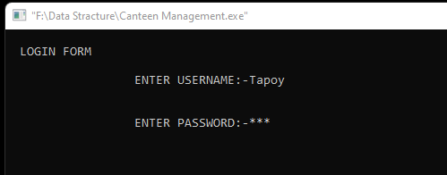

First of all we should login with User Name and Password

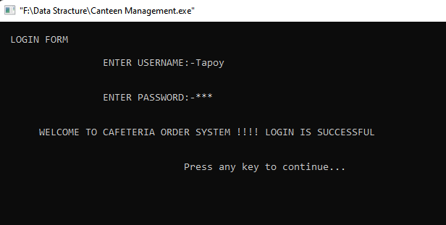

Login Successful Then go to next step

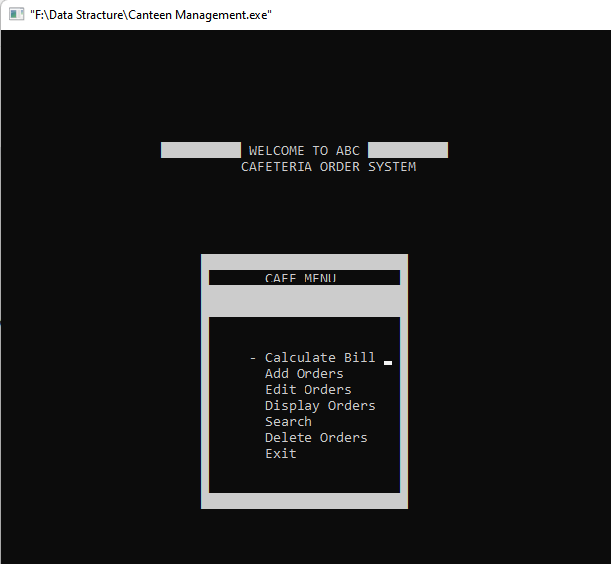

That is menu bar where you want to go just type enter.

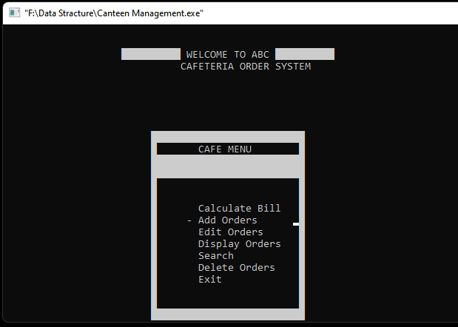

First of all we wants to Add Order so go to add order option and then typ enter button.

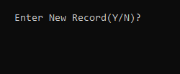

If new record press Y Otherwise N

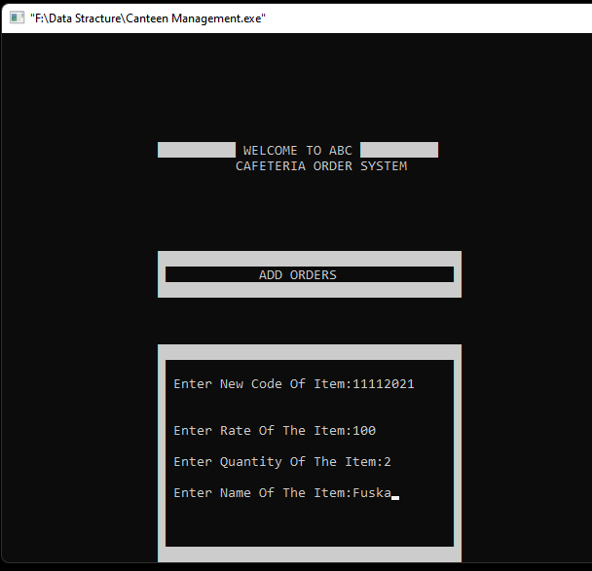

Then we give item code rate quantity name then press enter

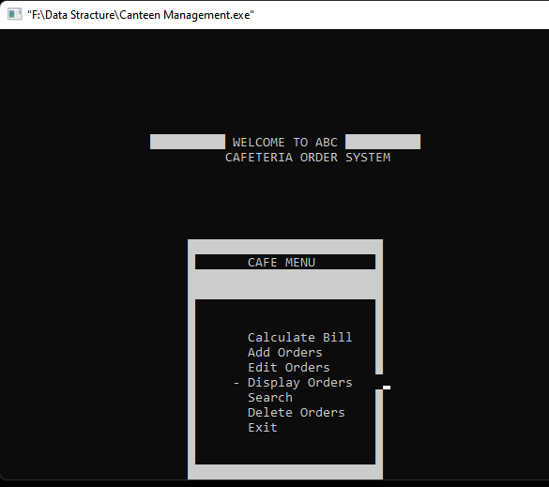

How many order we make if you want to see go to display option and then press enter.

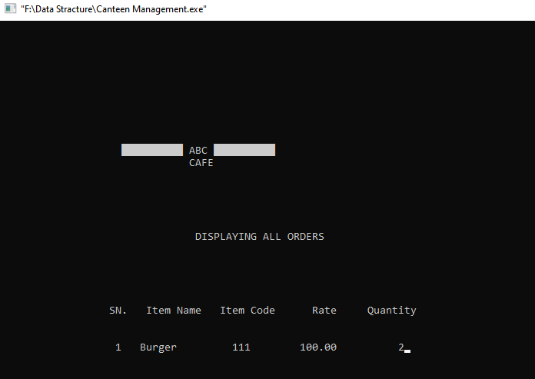

That is order list

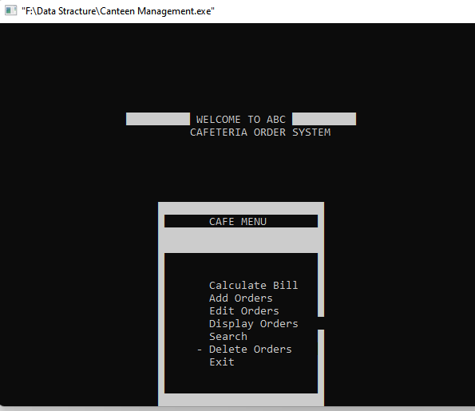

We can also delete order by this

That is commplete output how to use that management system.

# Chapter 4

**Conclusion**

**3.1 Introduction**

Completely Automated Canteen process from Generation of Canteen Slip Combination Of Hardware & Software Hardware to Order of food Using User Credential Software for process the Order Items System to generates Various Types of Consumption Report User data are send to payroll / Billing Software for Further Process. There are two sections;

H. Employees and Owners. The owner can add the employee details and update and view the records. The employee also manages sales and orders in the canteen. There are options such as log in, inventory, sell, record, order, manage staff, etc. The user has to keep the inventory, i. H. Update the price of the item and the quantity each time you start the program. Otherwise, the invoice and various modules will show the garbage value

**3.2 Scope of Future Work**

Canteen Management System Future is good. Because now our world is on internet depended. And Every School College and University Have Canteen when Students get Tiffine time then they will go to buy something for eat so that there happens so many problem. If we give our progject plan then every one buy this project from us. So that Canteen management Is important.